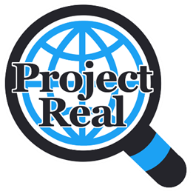

Project Real

Project Real is a project developed by young people, teachers, social media influencers and academics. It aims to help young people develop the skills to recognise fake news online. The project is led by Dr Yvonne Skipper from the University of Glasgow and has been funded by Not Equal.

We know that fake news spreads six times faster than the truth and that people believe it 75% of the time, so we wanted to create a project to help young people to recognise fake news. However, a lot of the existing Fake News projects have been designed by adults, for adults and do not reflect the experiences of young people. We decided to co-create Project Real with young people to ensure that the sessions and materials were engaging and relevant. Three schools in Glasgow worked with us for 6 weeks to design the activities in the programme.

Furthermore, we know that young people do not always trust ‘experts’ but they trust social media influencers. Project Real uses videos and content from social media influencers discussing their own experiences to make the content relevant and engaging for young people.

Each session covers a different topic:

1***. Fake News***

2. ***Fake Photos***

3. ***Fake People*** (fake profiles on social media)

4. ***Fake Stories*** (conspiracies)

5. ***Fake Videos***

6. ***Teaching Younger Years*** (where students design activities based on their learning to help others)

Each session is based on the UK’s Government ‘SHARE’ guidelines and includes a starter, main activity and closing activity as well as a range of videos. We have developed PowerPoint slides (with notes sections and embedded videos) and a teacher guide for each session.

If you have any comments or thoughts as you deliver the project to help us improve it, please contact [Yvonne.Skipper@](mailto:Yvonne.Skipper@glasgow.ac.uk)glasgow.ac.uk

Many thanks for all your help with this project!

*The Project Real team*

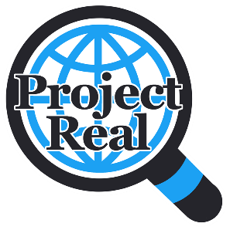

**Session 1: Fake News - Teacher Guide**

The materials for the session can be found on the PowerPoint (“Fake News”). The PowerPoint has notes which outline the timings and other information which might be useful. This session should take around 50-60 minutes. You do not need any equipment for this session except a projector. The session is based on small group work/paired work.

The aims of this session are to teach students:

1. What fake news is
2. How to use the SHARE checklist.

**PLAN FOR THE SESSION:**

* The session starts with a welcome video from the Project Real team to explain the project (around 5 minutes).
* The first starter activity is a pair or small group discussion on fake news (around 5 minutes).
* The second starter activity is a pair or small group discussion and written task, where students are asked to note how they know if news is real or fake and what they do about it if news is fake (15 minutes).
* We then include a slide on the SHARE guidelines. You can explain these yourself, but we also provide a video with Dr Yvonne Skipper which discusses how to use them to spot fake news (5 minutes).
* The main activity involves showing some examples of news and asking students in small groups to use the SHARE checklist. Please show each one and give students time to discuss. We have provided 10 examples, you can choose a ‘quick fire’ discussion of all of them, or select a few to discuss in detail. Whether the examples are true or false is included in the notes section. Please encourage students to use the SHARE guidelines (Source, Heading, Accuracy, Retouched and Errors) in their discussions (20 minutes).
* The final activity is a short discussion about the main activity (5 minutes) you can skip this if you do not have time. There is a final slide on how they can use this information in their other lessons.

The session next week will focus on Fake Photos.

If you have any comments or thoughts as you deliver the project to help us improve it, please contact [Yvonne.Skipper@](mailto:Yvonne.Skipper@glasgow.ac.uk)glasgow.ac.uk